Theoretical neuroscience: Tuning Curves and Receptive Fields
Date: 12/12/19
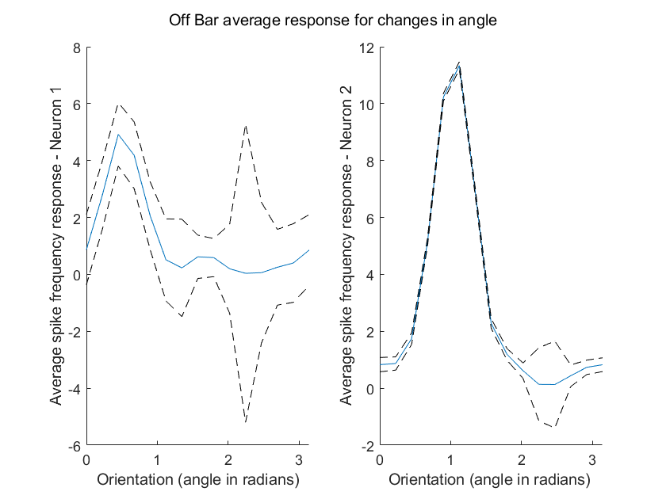
Figure 1: Tuning curve for neuron 1 and 2; average spike response vs angle (off bar).
We can see both neuron 1 and 2 both have particular affinities to a specific stimulus orientation (Neuron 1 ≈ 0.5 radians & Neuron 2 ≈ 1 radian). The blue line indicates the weighted average response whereas the dotted lines indicate the our variation limits of the response.
We do observe some strange increases in variations at angles that appear to be approximately perpendicular to the peak spike frequency angles. I.e. distances appear to be ≈ 1.5 radians ≈ pi/2.

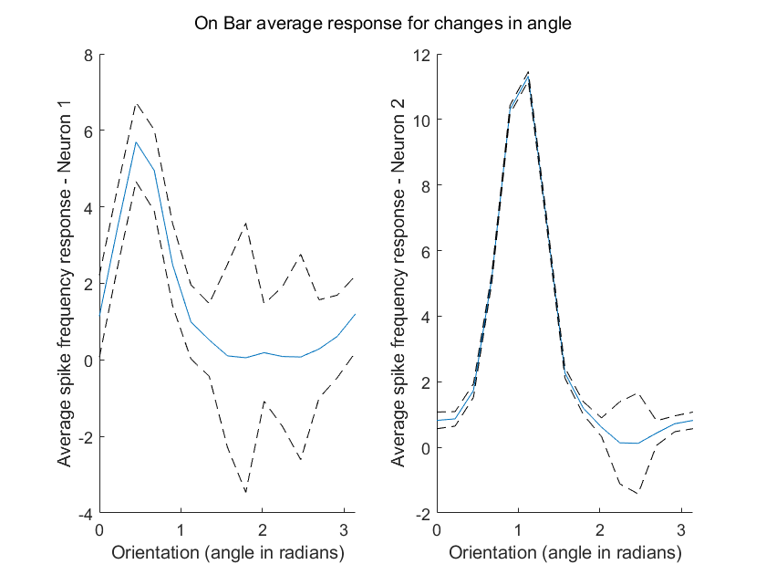
Figure 2: Tuning curve for neuron 1 and 2; average spike response vs angle (on bar).

Again we see the same average frequencies corresponding with specific orientations for both Neuron 1 and 2.
We see this same behaviour of increased variation at a perpendicular angle to our favoured orientation.
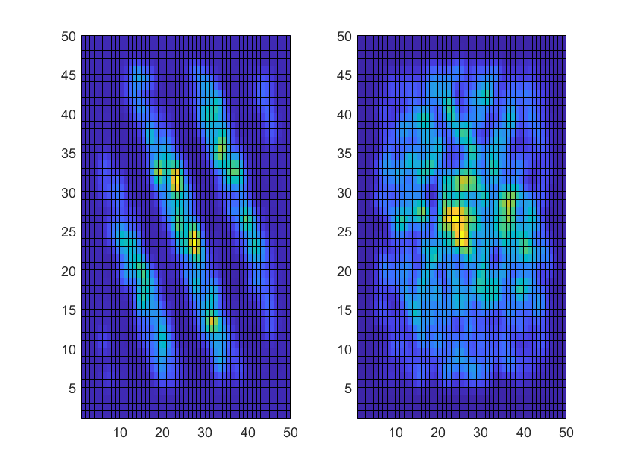
Figure 3: On spot response weighted average for neuron 1 and 2.

In this figure we can see the response of both neurons to an ON spot against an OFF background. The responses for neuron 1 are stronger when the stimulus hits particular spots on the receptive field, forming an overall striped pattern. For neuron 2, the response is less specific, this gives us a less clear representation of the linear filter of neuron 2.
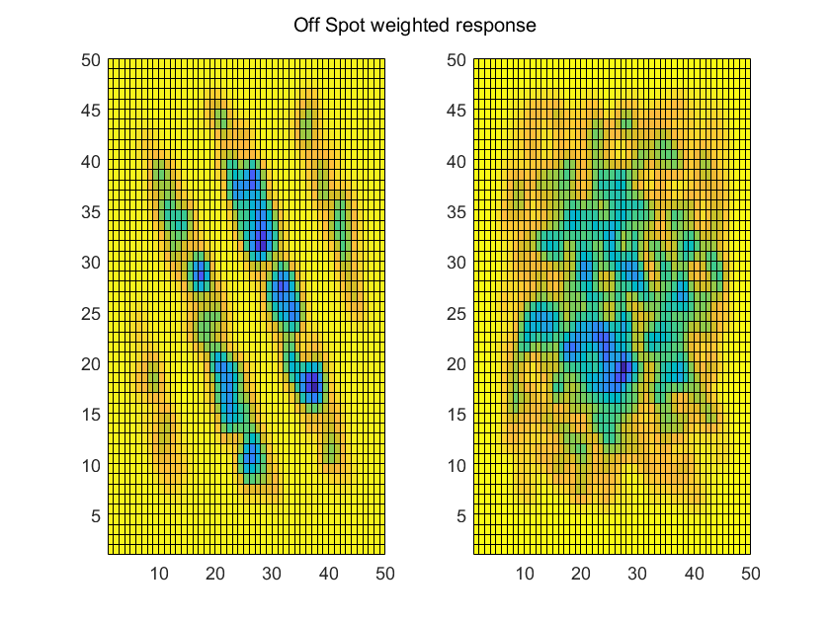
Figure 3: Off spot response weighted average for neuron 1 and 2.
In this figure we can see the response of both neurons to an OFF spot against an ON background. The responses for neuron 1 are stronger when the stimulus hits particular spots on the receptive field, forming an overall inverse striped pattern. For neuron 2, the response is less specific, this gives us a less clear representation of the linear filter of neuron 2.
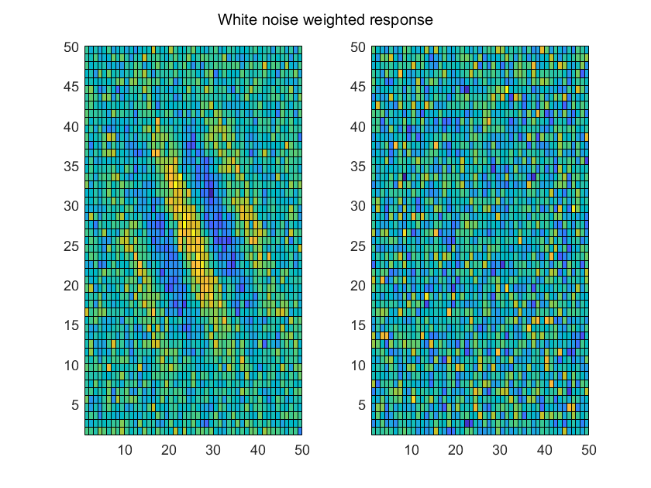
Figure 4: White noise weighted response for neuron 1 and neuron 2- Here, we can observe the responses to a white noise stimuli for both neurons. For neuron 1, the pattern observed on the image confirms the specificity of the receptive field for the stimulus; however, this is not true for neuron 2 as no pattern is observed.

Optional:

Response weighted average covariance:

Neuron 1

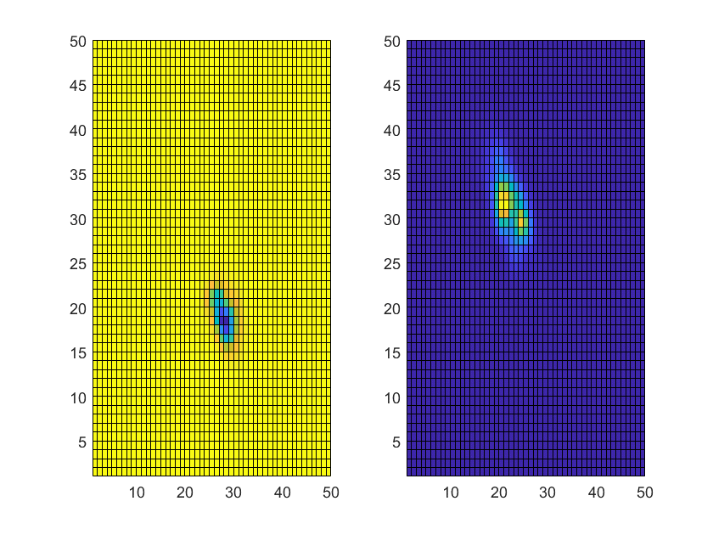

Figure 5: Principal eigen vector receptive fields 1, 2 – OnSpot Neuron 1.

Applying the weighted response technique to neuron 1 we can uncover some of the key components of receptive field. However in this case, this is not any more informative than our earlier testing that gave us a clear receptive field.

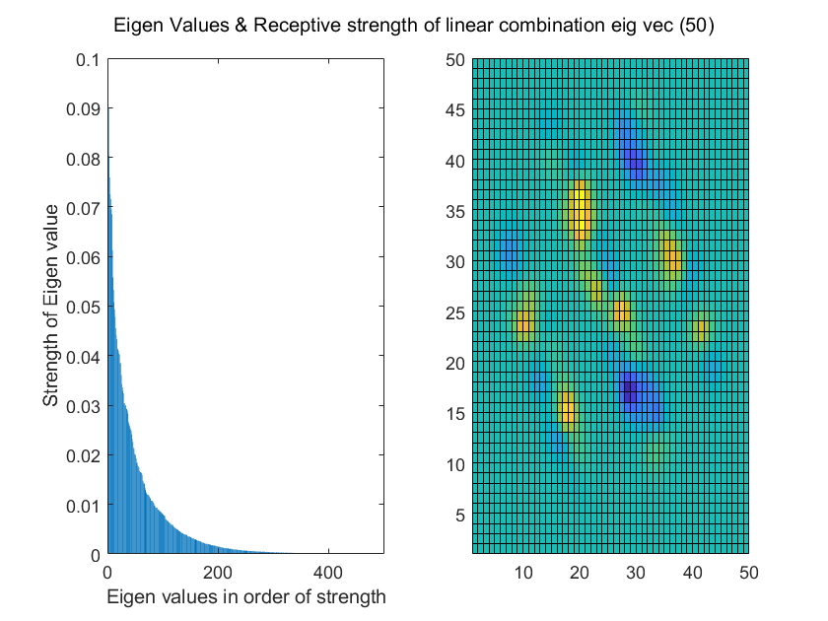

Figure 6: Eigen values and a linear combination eigen value receptive field neuron 1.

Here we can observe the strength of some of the eigen vectors and observe that there is only a small amount of contribution from the 2500 values decomposed. Furthermore, we can see on the right a linear combination of the first 50 eigen vector receptive fields, giving us a combined heat map representation of the most dominant filtering/responsive regions of the neuron.

Neuron 2:

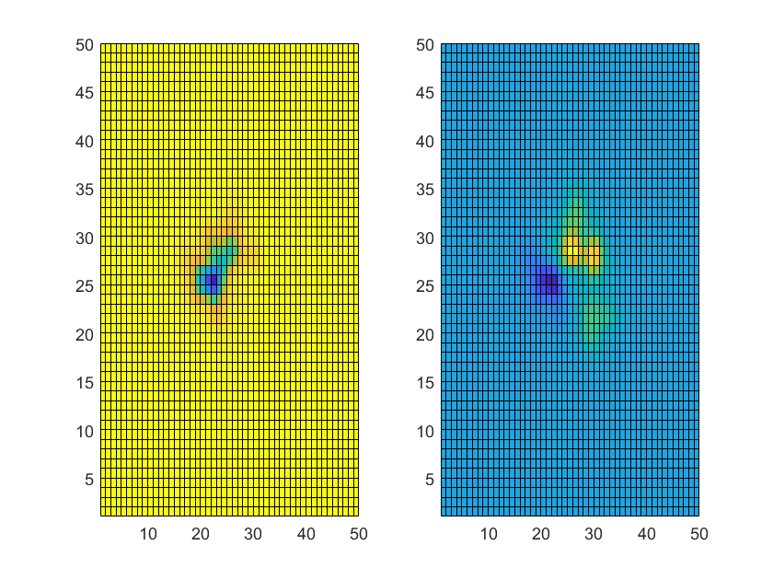

Figure 6: Principal eigen vector receptive fields 1, 2 – OnSpot Neuron 2.

Here we can see some of the more influential filters of Neuron 2, these appear to be showing a more centralized/circular response. This is somewhat similar to the earlier responses from this neuron and the average weighted response.

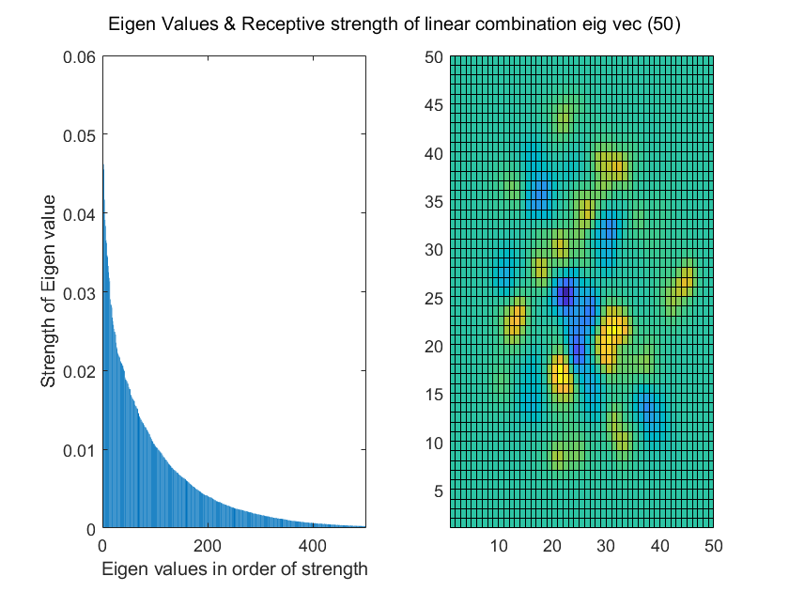

Figure 7: Eigen values and a linear combination eigen value receptive field neuron 2.

Here we begin to see some of the more dominant filters combined in Neuron 2 through our linear combination. At this stage it appears to be dominantly responsive to more diffuse patters of varying contrast, such as spotted or more detailed arrays of color.

